CONFIGURING DHCP SERVER (SERVER 1) & CLIENT (SERVER 2) in Centos 7

Step 1: Install Required Packages
Step 2: Prepare the Configuration File
Step 3: Configure the Linux DHCP Server
Step 4: DHCP Client Side Configuration (Server 2)

CONFIGURING DHCP SERVER (SERVER 1)

Step 1: Install Required Packages
1. Make sure VMWare is connected to the Internet. (NAT) To test internet connectivity, ping google.com / open any website using Firefox.
2. Install required packages and dependencies for Linux DHCP Server.
#yum -y install dhcp*
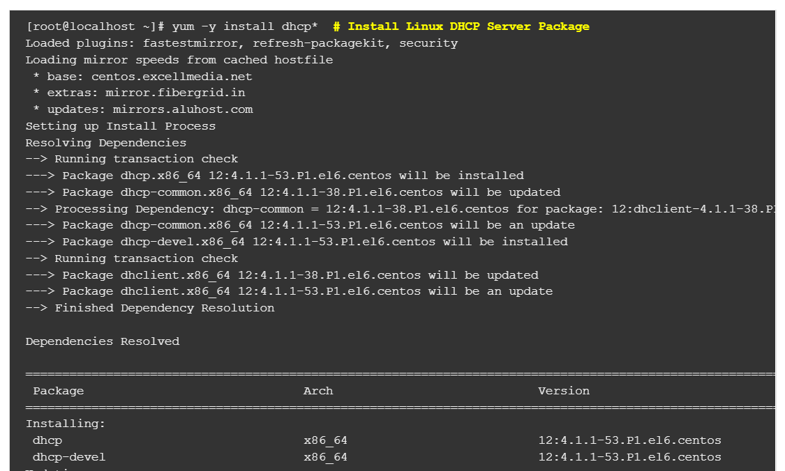

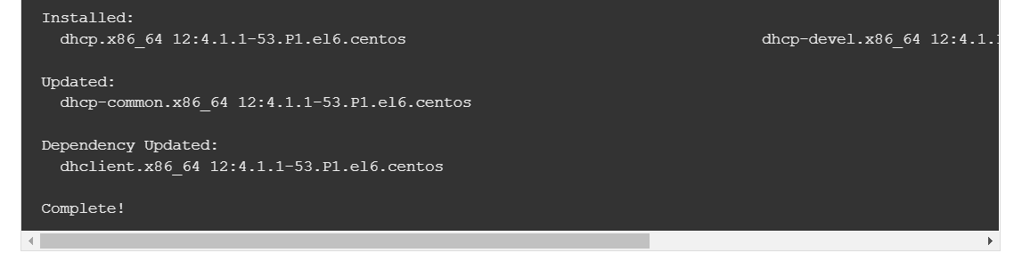

3. You can confirm if packages are properly installed or not by using below command.
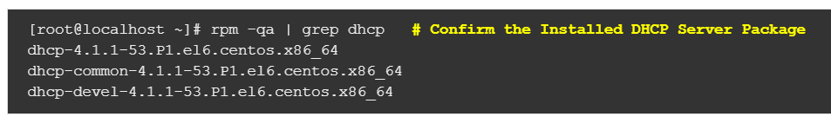
4. After installation let’s check what is the Installation directory of Linux DHCP Server and Path of all configuration files. We can do so using below command.
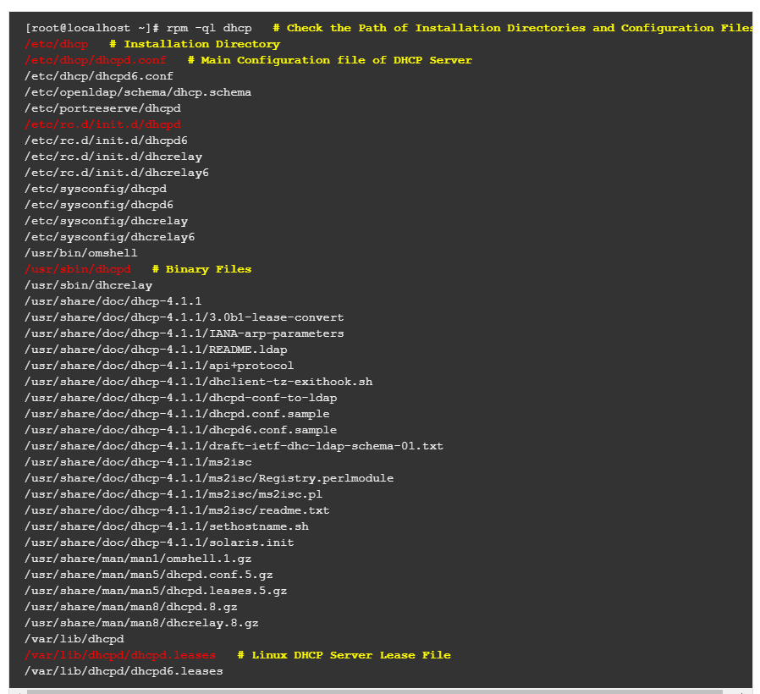
5. The installation directory of DHCP Server is /etc/dhcp and the main configuration file of Linux DHCP Server is dhcpd.conf. By default the dhcpd.conf file would look like as shown below. As you can see below there is a message for us that we can copy the sample dhcpd.conf file from /usr/share/doc/dhcp* directory.
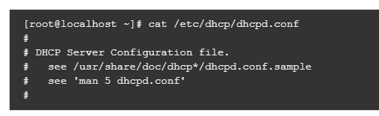

Step 2: Prepare the Configuration File
1. So let’s go ahead and copy the dhcpd.conf.example file as dhcpd.conf. System will ask for Overwrite as we already have dhcpd.conf file at /etc/dhcp path. So just enter yes and Press enter to continue the Copy.

Step 3 : Configure the Centos DHCP Server
1. Change to Host-only in Network Adapter.
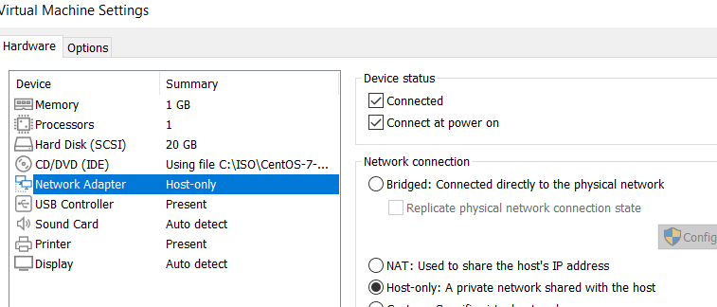

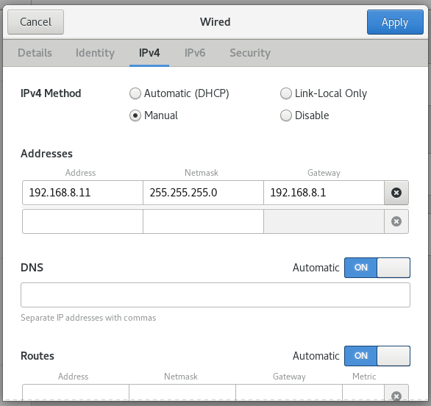
2. Change the IP Adress details and choose IPv4 method as Manual. Click Apply.

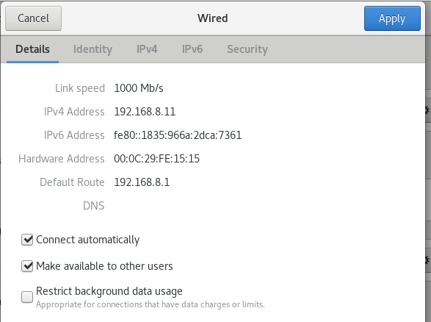
3. Make sure the IP address will change as above.

4. Below shown configurations are global variables and will apply to all subnet’s we declare on dhcpd.conf file. So just edit the configuration file and make changes as per your scenario.
vim /etc/dhcp/dhcpd.conf
Comment all except (grey font) as below:

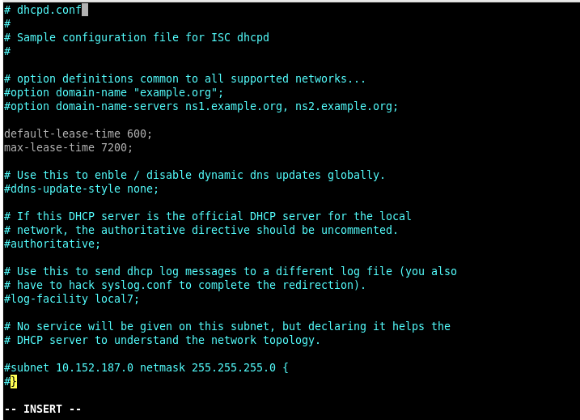
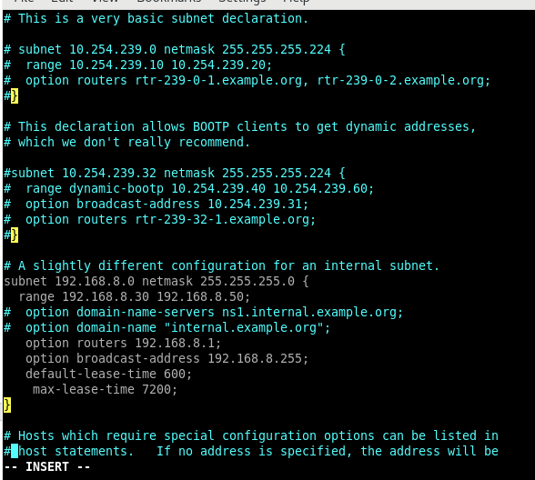
5. Change the info (subnet, netmask, range, option routers, option broadcast-address) according to the details above.

Where :
Range is for allowed IP Address Range i.e. 192.168.8.30 to 192.168.8.50. DHCP Server will assign IP Address to client computers within these range.

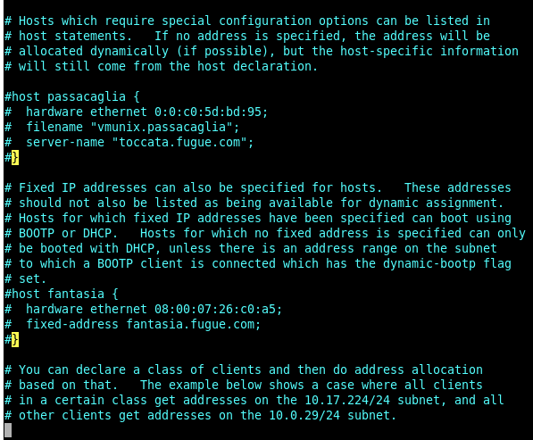
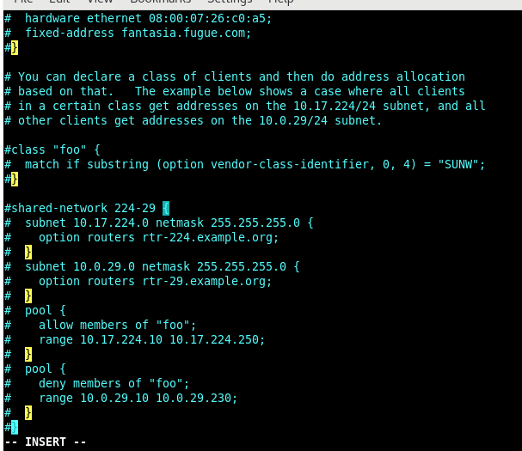

6. Save and exit from the file. (:wq)

7. Setting for firewall
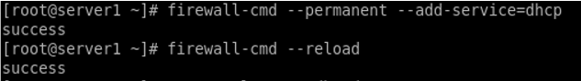

8. Start and enable dhcp services.
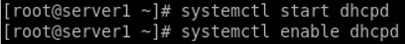
If there is any error appear after these two commands, meaning there are errors on the main configuration file, and network settings.

9. To check dhcp status
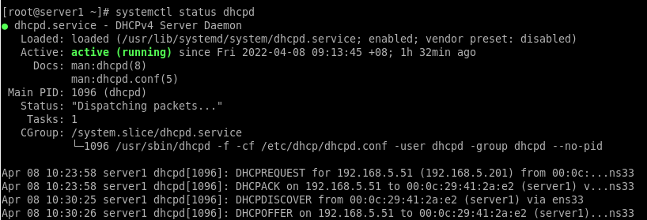

*** Whenever the main configuration (dhcpd.conf) had changed, you need to restart the dhcp service at Server, and restart network at Client.
systemctl restart dhcpd
systemctl enable dhcpd
systemctl status dhcpd

CONFIGURING DHCP CLIENT (SERVER 2)

Step 4: DHCP Client Side Configuration
Open server 2 ( svr2):

1. Set Host-only in Network Adapter.

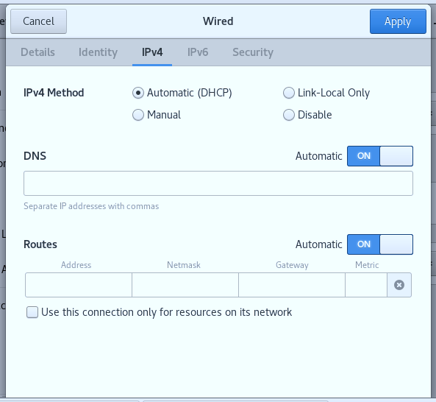
2. Choose ‘Automatic (DHCP). Click Apply.

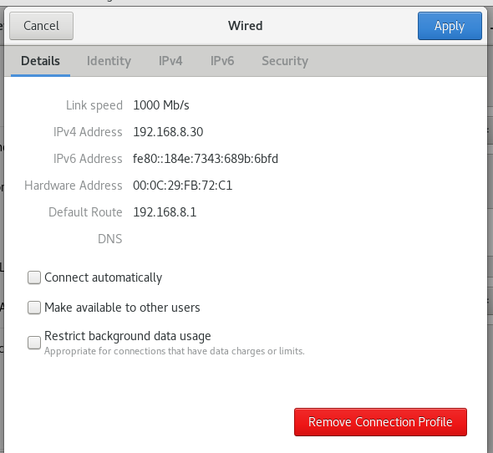

Please refer to Troubleshooting Notes, if this step is not successful.

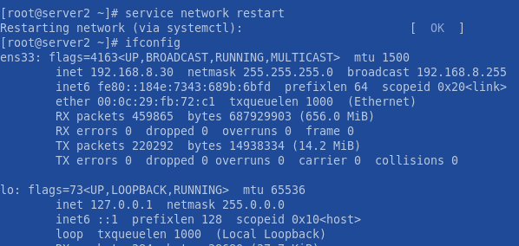
3. The client successfully get the IP address from the DHCP server’s range of IP address. Make sure inet address is between the range of IP addresses that has been set up in server side. In this example, the range IP address is 192.168.8.30- 192.168.8.50.

GOOD LUCK! 😊

Troubleshooting Notes
1. If client still unable to retrieve IP address from the DHCP server, try to change Network Adapter in Virtual Machine Setting, to Custom: Specific network (choose any vmnet) . Make sure do the same thing at server (SERVER1 ) side, and choose the same vmnet as Client. Both server and client need to have the same vmnet.
Or
2. Untick “Use local DHCP service to distribute IP address to VMs” in VMware Workstation 15 Pro.
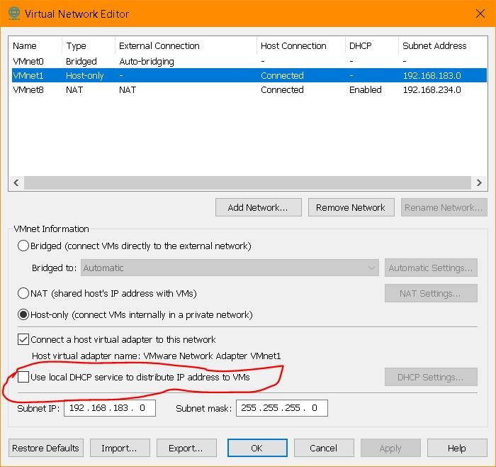
Credited to : Khairul Amri -Sem4 NWS2 ( Jan2022)

